Justin Comer, Connor Toale, Dylan Clark

Final Replacement Project and Project Phase 2

Cd, mkdir, rmdir

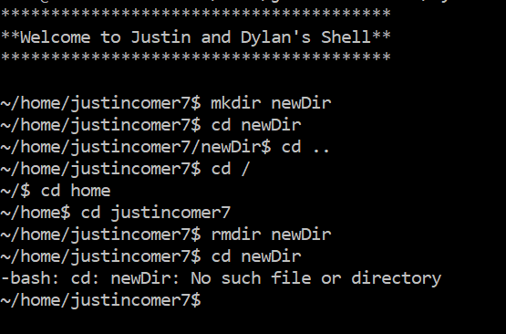

Sleep, Timeout, and Stat

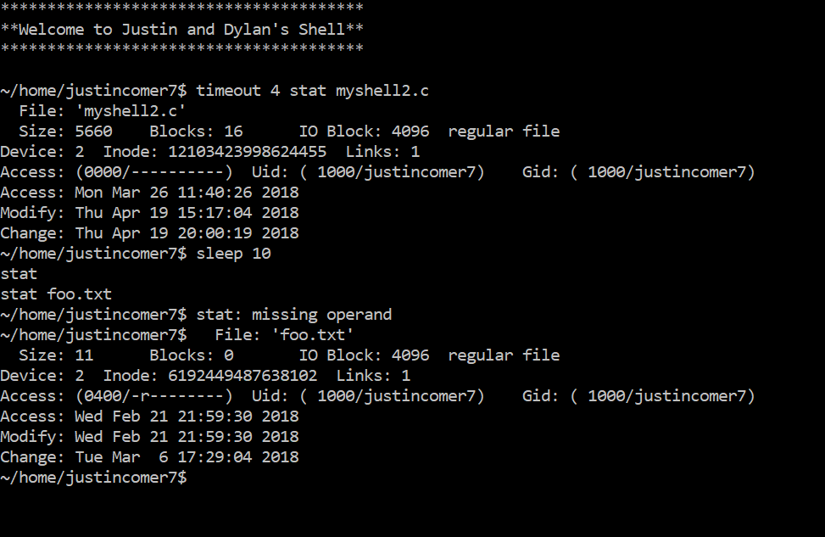

Env

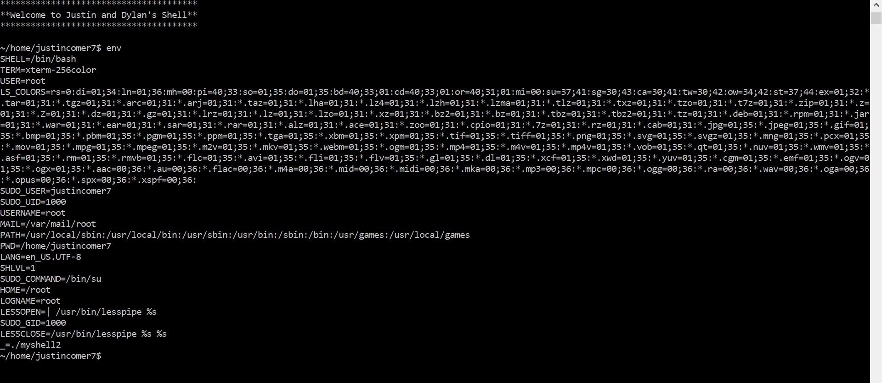

Kill

